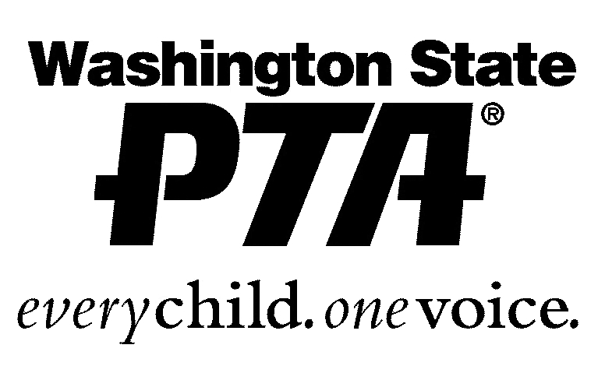

2017 PTA INDIVIDUAL AWARDS

The Penny Creek PTA has the opportunity to recognize and award individuals who have provided outstanding opportunities for children and youth that are beyond the normal scope of their jobs or volunteering. We are looking to recognize those people who are going above and beyond the normal volunteer service. This could be a person who volunteers with the PTA, their local church, schools, or sports as well as someone who works with youth organizations such as the Girl Scouts, Boy Scouts, or Campfire. You may nominate a person for 1, 2, 3, or all categories. Past winners are not eligible for the same award. Please send your completed form in a sealed envelope marked PTA Individual Awards. Please attach an additional sheet of paper if you need more room to describe your nominee.

Golden Acorn
The Golden Acorn Award is presented by a local PTA or council to a volunteer in recognition of his/her dedication and service to children and youth. Since the beginning of this program, more than 44,000 Golden Acorns have been presented to volunteers throughout Washington State.
Past Winners:
2016- Shanley Halvorson
& Alisa Yee
2015- Kira Monica
2014- Heather Emans &
Linda Evans
2013- Debbie Cresanti &
Andrea Rosen
2012- Tami Fischer &
Stephanie Sprink
2011- Shobhna Hendry &
Britt-Marie DeForeest
2010- Kristina Monten

I Nominate: _________________________________________________
He/She deserves this award because:______________________________ ________________________________________________________________________________________________________________________________________________________________________________________________________________________________________________________________________________________________________________________________________________________________________________________________________________________________________________________________________________________________

Outstanding Advocate Award
Recognizes and honors an individual for continued and dedicated service to ALL children, and a demonstrated commitment to helping create strong policies relating to the health, welfare, safety, and education of children and youth. Recipients will receive a certificate and pin, and a contribution is made in their name to the WSPTA Scholarship Program.
Past Winners:
2016- Evelyn McEwen
2015- Glenna Dujenski
2014- Chad Golden &
Andrea Rosen
2013- Joanie Klorer
2011- Jenny Forbes
2010- Deanna Ramirez

I Nominate: _________________________________________________
He/She deserves this award because:______________________________ ________________________________________________________________________________________________________________________________________________________________________________________________________________________________________________________________________________________________________________________________________________________________________________________________________________________________________________________________________________________________

Outstanding Educator Award
The Outstanding Educator Award may be presented by local units, councils, and WSPTA to honor outstanding educators who have provided outstanding educational opportunities for children and youth that are beyond the normal scope of their jobs.
Past Winners:
2016- Shelly Bratton
2015- Robin Mohr
2014- Jen Freeberg &
Sharon Park
2013- LouAnn Cordell,
Evelyn McEwen &
Tiffany Sparks
2012- Marilyn Donohew &
Tina Farias
2011- Kathi MacDonald
2010- Emily Cheever

I Nominate: _________________________________________________
He/She deserves this award because:______________________________ ________________________________________________________________________________________________________________________________________________________________________________________________________________________________________________________________________________________________________________________________________________________________________________________________________________________________________________________________________________________________
____________________________________________________________
____________________________________________________________

Honorary Life Membership
The purpose of the Honorary Life Membership is to honor an individual who has contributed significantly to a PTA at the local unit, council, or state level. This award can be given by a PTA unit, council, or region.
Past Winners:
2016- Debbie Cresanti
2012- Deanna Ramirez

I Nominate: _________________________________________________
He/She deserves this award because:______________________________ ________________________________________________________________________________________________________________________________________________________________________________________________________________________________________________________________________________________________________________________________________________________________________________________________________________________________________________________________________________________________

Form submitted by: ___________________________________________

Phone or email:_______________________________________________

Questions? Email Alisa Yee (alisapcepta@yahoo.com)

****Please return form by Thursday 3/16/17.****

