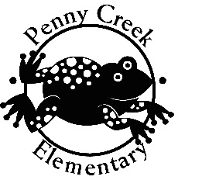

**Please join us for our**

**2017 Festival of Cultures**

**Date: Thursday, March 9, 2017 from 6:30 – 8:30p.m.**



Join us at our school for a fun night of multi-cultural activities!

Enjoy handmade authentic food, music, dance, activities and more!

Prizes will be given away throughout the event!

Free

admission and food samples!

**All children will receive a passport to learn about other cultures.**

**Brought to you by our Penny Creek families and our Natural Leader parents!**